Concept Note: Gyarah Das - A Voice-Based AI Companion for the First 1000 Days of Mother and Child Care

Background

The first 1000 days, from conception to a child’s second birthday, represent the most critical developmental window in human life. Maternal nutrition, antenatal care, institutional delivery, newborn care, immunization, early stimulation, and responsive caregiving during this period shape long-term outcomes related to survival, cognition, health, learning, and productivity.

India has built an extensive maternal and child welfare ecosystem through:
- frontline workers
- Anganwadi systems
- primary healthcare infrastructure
- nutrition programs
- immunization platforms
- maternal benefit schemes
- referral transport systems
- digital health initiatives
Despite these investments, many mothers continue to experience:
- delayed antenatal care
- anemia
- missed immunizations
- low entitlement awareness
- delayed referrals
- weak postnatal follow-up
- fragmented service access
- discontinuity across programs
The challenge is not merely lack of schemes or service providers. The challenge is the absence of a continuous demand generation and engagement layer that helps mothers navigate and activate the existing safety net at the right time.

Maternal and child health service delivery involves multiple touchpoints across health, nutrition, and community systems, creating a need for continuous beneficiary engagement and navigation support.

There is a need for a conversational, multilingual, voice-first AI layer that continuously engages mothers, generates timely service demand, and intelligently connects them with existing public and community-based support systems throughout the 1000-day journey.

The Gyarah Das Framework

Gyarah Das is a structured maternal-child lifecycle framework built around:
- 11 = structured developmental and care quarters
- ±10 days = adaptive childbirth transition period
- continuous engagement across the first 1000 days
The framework converts the broad “1000 days” concept into measurable quarter-linked care pathways, service triggers, and demand-generation opportunities.

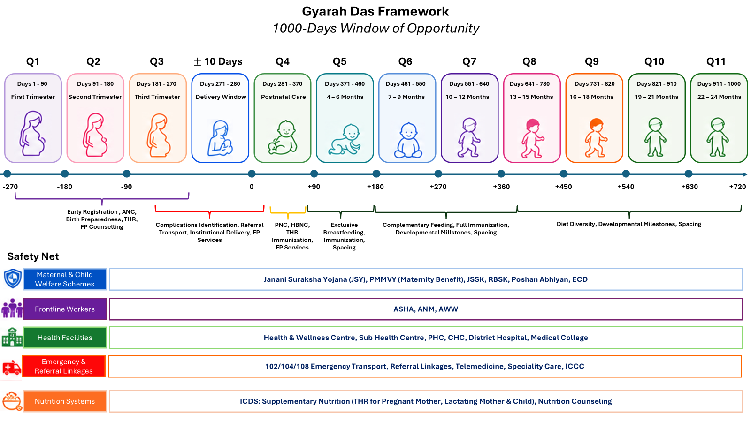

Each quarter represents:
- a predictable set of maternal-child needs
- expected service entitlements
- developmental milestones
- nutrition requirements
- risk windows
- system touchpoints
Vision

To build a voice-based AI companion that strengthens maternal and child outcomes by continuously generating informed demand for existing services, entitlements, and safety-net interventions during the first 1000 days.
Core Concept

Gyarah Das is designed as a:
- voice-first
- multilingual
- low-literacy friendly
- AI-enabled
- lifecycle-aware
The system interacts with mothers continuously based on their current quarter in the 1000-day journey.
Instead of waiting for mothers to independently seek care, the system proactively generates:
- reminders
- entitlement awareness
- nutrition guidance
- developmental prompts
- service demand signals
- referral requests
- escalation alerts
- continuity tracking
Demand Generation Perspective
The central innovation of Gyarah Das is shifting maternal-child healthcare from passive availability of services toward active generation of informed demand.

The platform continuously identifies:
- what services are due
- what benefits remain unaccessed
- what risks are emerging
- what referrals are needed
- what follow-up is pending
The AI companion helps mothers ask for and access services at the correct time.

Examples include:
- ANC visits
- anemia screening
- immunization
- take-home rations
- institutional delivery
- breastfeeding counseling
- developmental screening
- nutrition support
- referral transport
Connecting Existing Safety Nets
Gyarah Das is designed to strengthen utilization and coordination of existing systems, including:

Frontline Workers
- ASHA
- ANM
- Anganwadi workers
Public Health Infrastructure
- Health & Wellness Centres / Sub-centres
- PHCs
- CHCs
- District hospitals
- SNCUs/NICUs
Nutrition Systems
- ICDS
- Poshan initiatives
- Supplementary nutrition programs
Maternal and Child Welfare Schemes
- Janani Suraksha Yojana
- PMMVY
- JSSK
- Immunization programs
Emergency and Referral Systems
- 102/108 ambulance systems
- Referral transport
- Telemedicine support
The platform acts as a coordination layer that helps mothers navigate these systems more effectively.

Conclusion
India has already invested significantly in maternal and child health systems through frontline workers, nutrition programs, public health infrastructure, welfare schemes, and digital health initiatives. However, availability of services alone does not guarantee timely awareness, access, utilization, or continuum of care services.

Gyarah Das is designed as a conversational engagement layer that supports timely awareness, navigation, and utilization of maternal and child services.

By combining:
- voice-based AI
- quarter-aware lifecycle intelligence
- proactive demand generation
- service orchestration
- and integration with existing safety nets
The platform aims to strengthen continuity, responsiveness, and utilization across the first 1000 days of life.

Gyarah Das intends to strengthen the continuum of care services across the first 1000 days through proactive voice-based engagement, timely service linkage, and sustained interaction between mothers and the broader maternal and child care ecosystem.

